Progress Update- HMP website

Name: Ulysses Urich Duran
Role: Designer
Tools/Frameworks Used: Figma, freefrontend.com

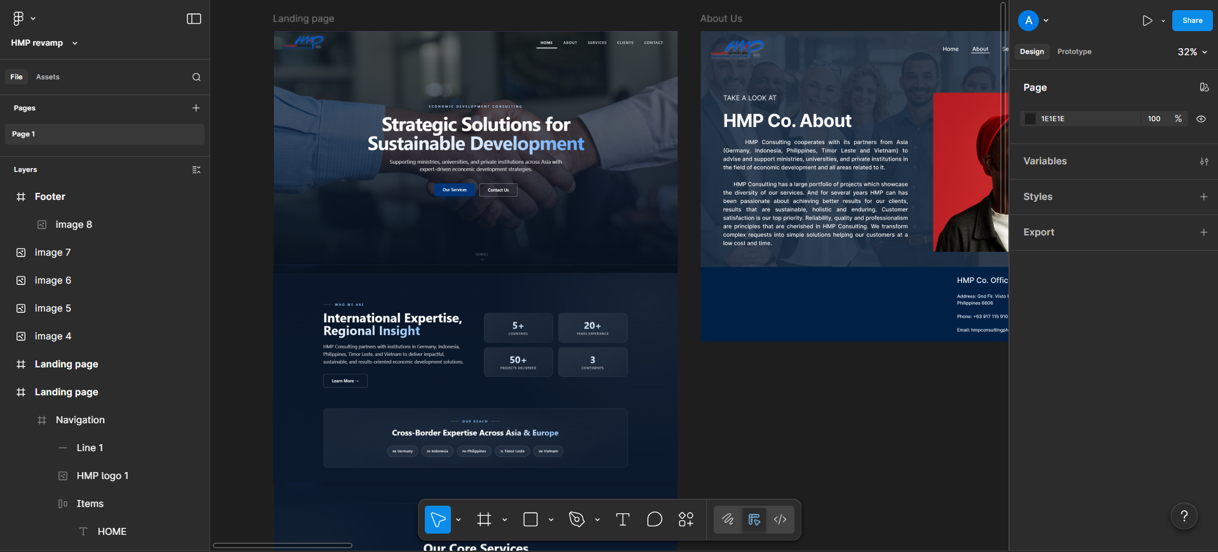
- The full design layout for the Home page has been completed.
- Sections, visual hierarchy, typography, and overall structure are finalized.
- Animations and responsive layout have been integrated.
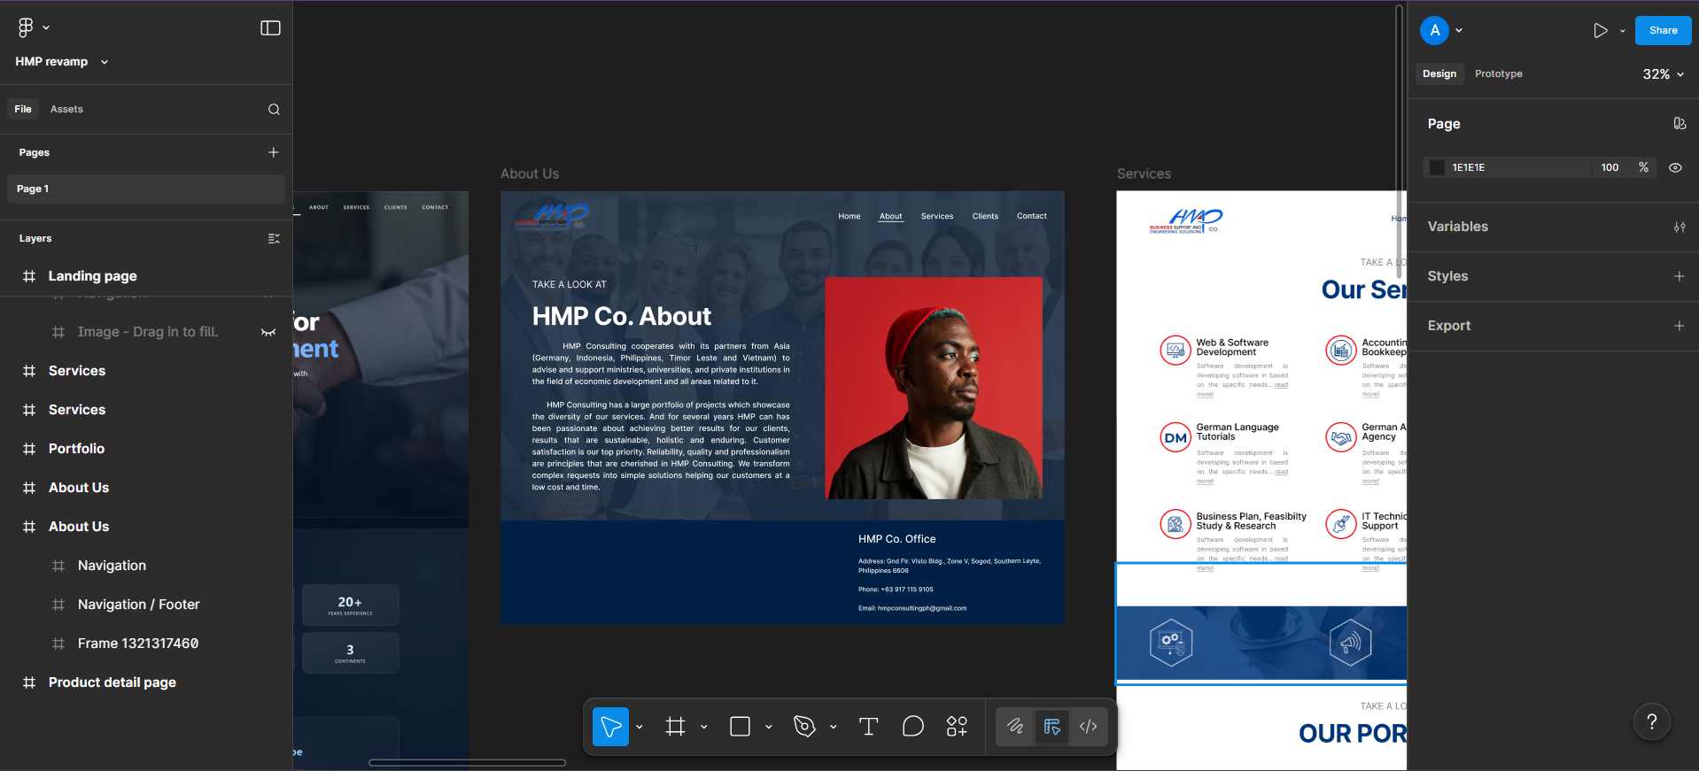
- The About page is currently in progress. Layout structure is being established, and content refinement is ongoing.
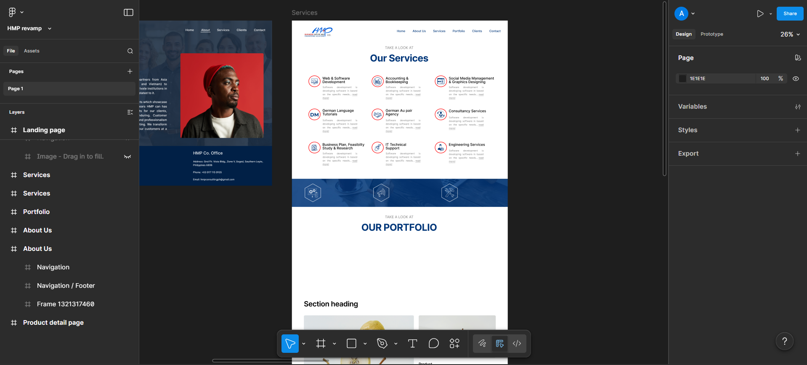
- The primary brand color scheme has been confirmed.
- The approved palette is now being applied consistently across all pages.
- Remaining internal pages are currently being updated to align with the finalized brand colors.
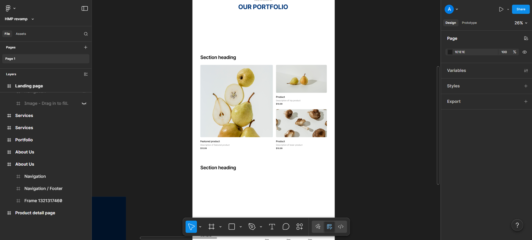
- Page structure and main sections are being established.
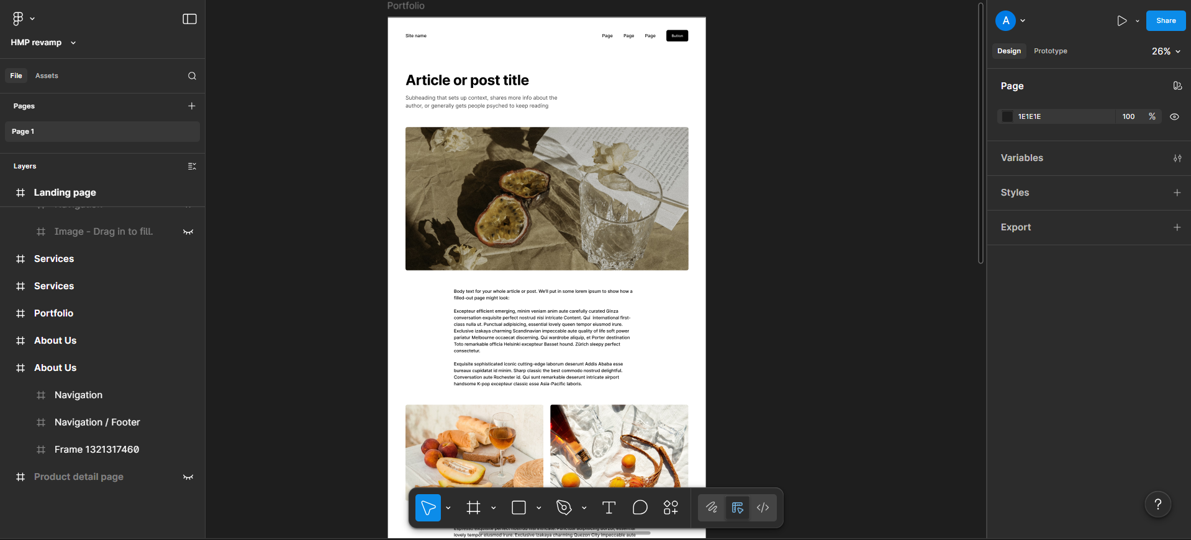
- Some textual content and specific section details are still being finalized and refined.
- Adjustments will be made once final content is approved.
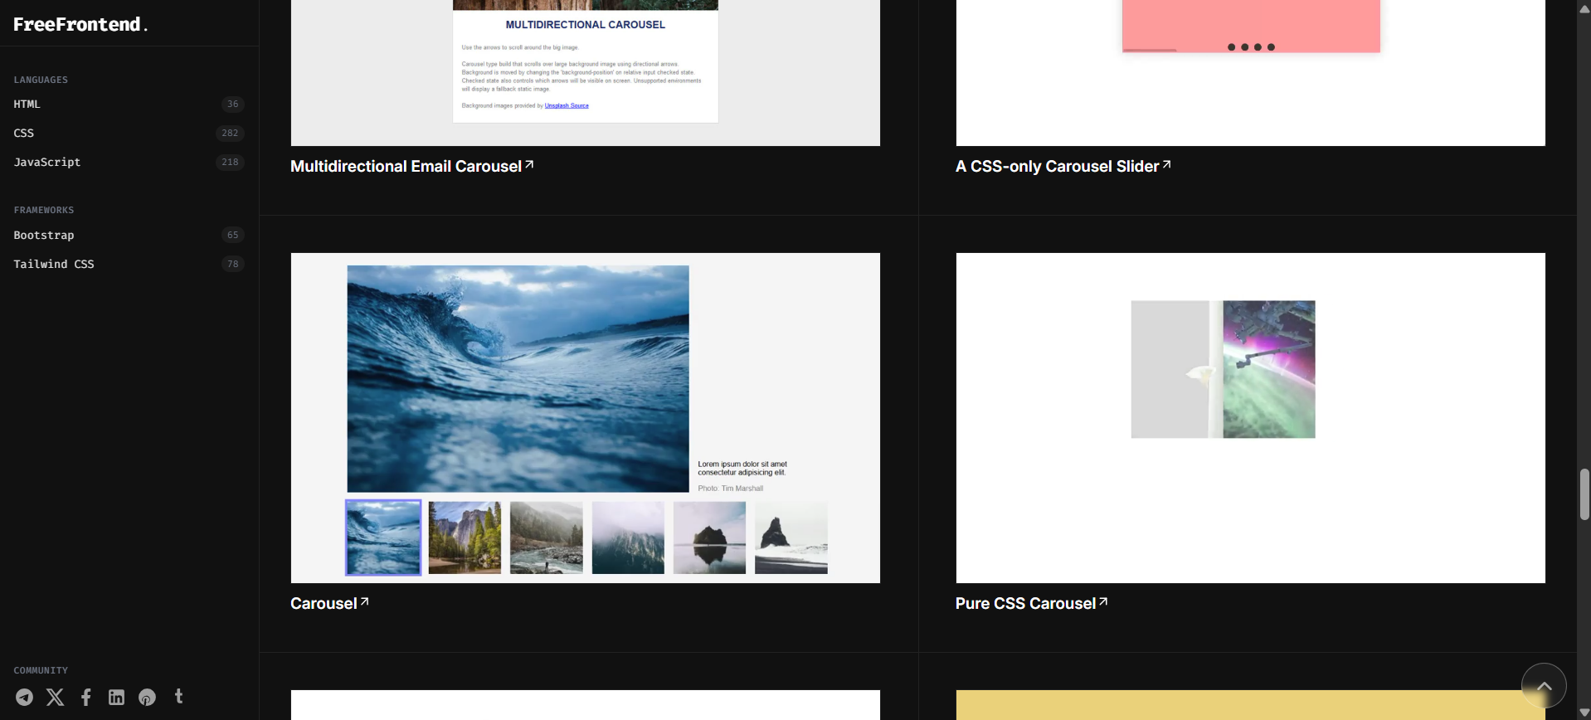

- Considering the integration of animated components to create a more dynamic and modern browsing experience for website users/clients.

